
For Immediate Release
Contact
Kelly Keiter
Publicist
VM Productions
kelly@notesthemovie.com
(818) 636-1755

VM Productions presents…
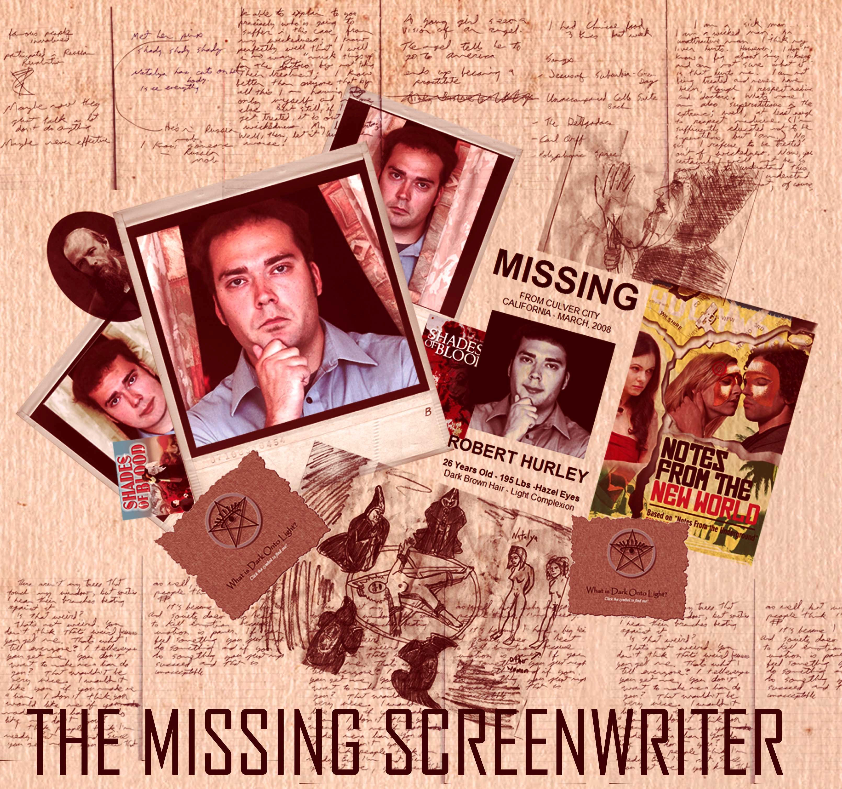
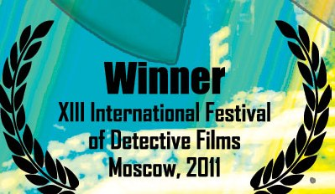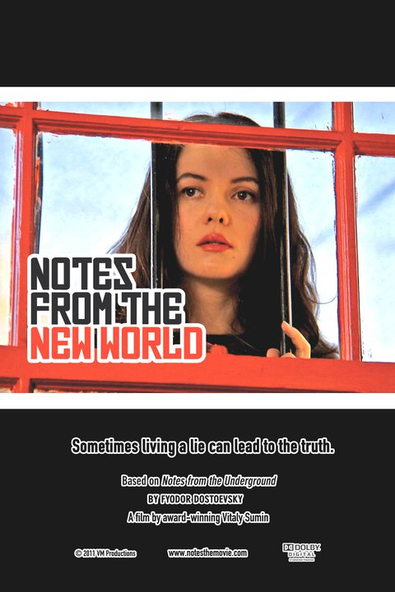
The provocative production “The Missing Screenwriter” to screen at
the 14th International Film Festival of Detective Films in
Moscow, Russia - April 25-29, 2012
www.detectivefest.ru
www.notesthemovie.com

2

VM PRODUCTIONS TO RELEASE DOCUMENTARY ON SCREENWRITER’S DISAPPEARANCE
By Vitaly Sumin (writer/director/producer)

In a strange case of Truth is Stranger than Fiction, a Los Angeles-based Screenplay writer Robert Hurley (27) has vanished, and his mafia and occult connections suspected in the disappearance seem to mirror the characters in the award winning film titled Notes From The New World (US -2011) for which he wrote the first draft. Could Robert ever be found?

THE PREDICAMENT
A group of filmmakers have taken a novel, which has made an influence on modern day, and are turning it into a cinematic masterpiece. Robert Hurley, screenwriter of the first draft of “Notes from the New World,” inspired by Dostoevsky’s “Notes from the Underground,” has vanished shortly after reporting that he was being harassed by unidentified individuals.
According to Hurley, he saw a figure of a tall man prowling around his car in the parking lot. Hurley stepped outside to shout and frighten the man, but the intruder made it out in time. Other reports show Hurley was experiencing frequent nuisances. Shortly after Robert Hurley informed VM Productions about his encounter with the prowler, he disappeared. A precious, original copy of the shooting script made in pencil with the director’s notes and breakdowns was stolen from Hurley’s home and a threatening letter was left on his desk. The investigation conducted by the company won’t go into detail about what was written in the note. All that is known is the threats had to do with his current script.
Clues have raised suspicions that the members of the Russian mafia may be to blame. “Notes from the New World,” tells the story of a young Hollywood actor who becomes tangled with a Russian prostitute and a Mexican immigrant. The Russian mafia plays a role in this film and isn’t shown in a positive light.
Neighbors say Hurley was a good man and can’t imagine he’d have any enemies. Rebecca Studel, his neighbor, would chat with him while he fetched his morning paper. “We would talk about how his script was coming along. I used to joke that I wanted to be in one of his movies!”
According to Vitaly Sumin, producer and director, although the film has been completed, Robert Hurley has never been found. “He would have wanted us to go on with the show!” If you have seen or heard anything, please contact VM Productions at vmpfilms@hotmail.com.

3
Attacks and Threats Sought to Shut Down Investigation

VM Productions recently announced plans to release a documentary about the events surrounding the mysterious disappearance of screenwriter Robert Hurley. The incident occurred as production was about to begin on the company’s new feature, Notes from the New World.

Hurley had written the first draft of the “Notes” screenplay. Director/producer Vitaly Sumin then prepared a detailed shooting script and gave it to Hurley, to be returned with his changes. If those pages weren’t found, production would be delayed by a month or more. This, Sumin felt, would jeopardize the entire production.

At first, Sumin suspected that the screenwriter was holding the shooting script hostage in order to inflate his credit in the final film. But another theory soon came to the fore—namely, that Hurley had run into trouble while researching the script, a contemporary re-imagining of Dostoevsky’s Notes from the Underground. Both Dostoevsky’s original story and the script delve into issues of human degradation and the underbelly of society.

Sumin launched an in-house investigation, to be carried out by key members of the film’s cast and crew. Events were documented on video as they unfolded. These included the discovery of Hurley’s romantic obsession with the film’s leading actress--and of his involvement with both a secret spiritual cult and a prostitute with connections to the Russian mafia.

The Missing Screenwriter: Robert Hurley’s Story also captures a film project on the brink. In the course of the investigation, property is damaged and stolen, threatening messages are received demanding that the film be stopped, colleagues come under suspicion, and key members of the cast and crew choose to abandon the production.

The startling raw footage is proof positive that truth is indeed stranger than fiction.
…………………………………………………………………………………………………
VM Productions is dedicated to developing and producing quality films based on original stories and the masterpieces of world literature.

# # #
Please review the following links:
http://www.imdb.com/title/tt1846778/ (IMDB entry – “The Missing Screenwriter”)
http://www.imdb.com/title/tt1558579/ (IMDB entry –“Notes From The New World”)
http://www.notesthemovie.com (“Notes From the New World’s” Web site)
More about Robert Hurley:
- Search for Robert Hurley: http://www.notesthemovie.com/the_search_for.html
- Robert’s blogs: http://www.notesthemovie.com/robert_blog.html
- Robert’s diaries: http://www.notesthemovie.com/robert_diary.html
-Robert’s Message to the World: http://lighttodark.bravehost.com/

NOTES FROM THE NEW WORLD – An Interview with Vitaly Sumin

By Ioanna Fotiades during the Corinth International Film Festival in Greece

http://www.youtube.com/watch?v=Dm6DZrykbmw
http://www.notesthemovie.com/Festivals-breaking-news-corinth.html

4

http://www.americanchronicle.com/articles/view/129603
(interview with Vitaly Sumin, director, producer and writer)

Interview with Vitaly Sumin by Daniela Loga and Donna West with The Voice of Russia - April 25, 2011 was broadcasted to 160 countries in 38 languages on short and medium waves, in the FM band, via satellite and through global mobil communications network, including the Internet
http://www.notesthemovie.com/vitaly_blog.html

